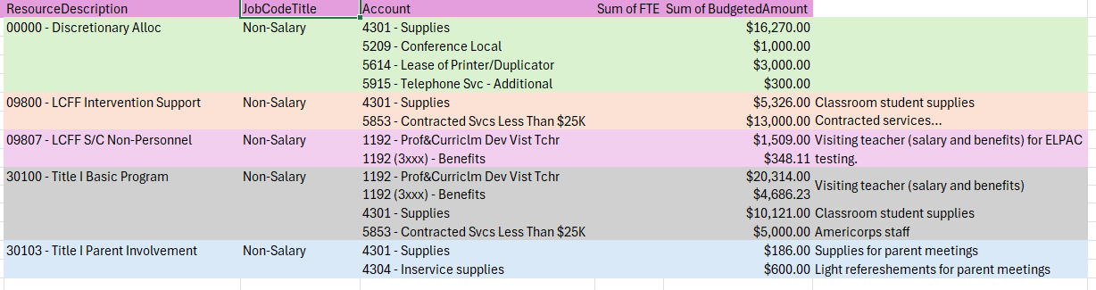

Transfer from: Title 1 Basic | To: Discretionary
(30100) = $993.71 | 00000Testing Headphones
(30100) = $925.92 | 00000RazzKids License

